# National biofouling management guidelines for marinas, slipways, boat maintenance and recreational boating facilities

Version 1.0, 2021

© Commonwealth of Australia 2021

**Ownership of intellectual property rights**

Unless otherwise noted, copyright (and any other intellectual property rights, if any) in this publication is owned by the Commonwealth of Australia (referred to as the Commonwealth).

**Creative Commons licence**

All material in this publication is licensed under a Creative [Commons Attribution 4.0 International Licence](https://creativecommons.org/licenses/by/4.0/legalcode) except content supplied by third parties, logos and the Commonwealth Coat of Arms.

Inquiries about the licence and any use of this document should be emailed to [copyright@agriculture.gov.au](mailto:copyright@agriculture.gov.au).

C:\Documents and Settings\west merryn\Local Settings\Temporary Internet Files\Content.Word\by.png

**Cataloguing data**

This publication (and any material sourced from it) should be attributed as: Marine Pest Sectoral Committee 2021, National biofouling management guidelines for marinas, slipways, boat maintenance and recreational boating facilities, Department of Agriculture, Water and the Environment, Canberra, January. CC BY 4.0.

This publication is available at [marinepests.gov.au/what-we-do/publications](http://www.marinepests.gov.au/Pages/map/American-slipper-limpet.aspx)

Marine Pest Sectoral Committee Secretariat

Department of Agriculture, Water and the Environment

GPO 858 Canberra ACT 2601

Telephone 1800 372 746 (local calls) +61 2 6272 5232 (international)

Email [mpsc@awe.gov.au](mailto:mpsc@awe.gov.au)

Web [marinepests.gov.au](http://www.marinepests.gov.au/)

**Disclaimer**

These guidelines are part of a series of documents setting out a consensus view of effective biofouling management practices.

The guidelines are made available on the understanding that the Commonwealth of Australia is not thereby engaged in rendering professional advice. The Commonwealth does not warrant the accuracy, currency or completeness of the guidelines, or their relevance for any particular purpose. In particular, it should be noted that legislation, regulations and by-laws may vary between different jurisdictions and ports in Australia. Consequently, the guidelines do not purport to state what is necessary or sufficient to comply with laws applying in any place.

Before relying on the guidelines in any important matter, users should obtain appropriate professional advice to evaluate their accuracy, currency, completeness and relevance for their purposes.

Contents

Introduction 1

1 Awareness 3

2 Environmental management systems 5

3 Infrastructure management 6

4 Vessel cleaning and maintenance 8

5 Record keeping and reporting 10

6 Surveillance 11

7 Reporting marine pests 13

8 Emergency preparedness 15

Glossary 16

Key references 17

Contacts 18

**Figures**

Figure 1 – Niche areas where biofouling can accumulate on a recreational vessel 9

**Photographs**

Photo 1 – Inspecting biofouling on marina pontoons 7

Photo 2 – Boat being cleaned and waste captured 8

Photo 3 – Inspecting mooring buoy biofouling at Weipa, Queensland 12

Photo 4 – Example of a marine pest detection response kit 14

## Introduction

Marine pests—non-native invasive marine plants or animals—can be introduced and spread (translocated) in a variety of ways, including as biofouling on the hulls of vessels, entanglement in deck gear and in niche areas such as damp or fluid-filled spaces including anchor lockers, bilges, sea chests or internal seawater systems.

The infrastructure that supports the operation of vessels (for example, boat harbours, marinas, slipways, recreational boating mooring areas and fishing ports/bases) provide hotspots for the introduction and spread of marine pests from both international and domestic vessels. The environmental conditions and artificial nature of these facilities make them highly suitable for marine pests to establish new populations once they are introduced. If marine pests are able to establish, the infested areas become a continual marine pest risk and are ongoing sources for domestic translocation to other pest-free locations within Australia.

Introduced marine pests can have significant impacts on the marine environment, people’s health and the economy. They can destroy marine habitats, cause localised extinction, displace native species, change water quality, foul infrastructure, block water uptake pipes and affect marine industries, tourism, fishing, aquaculture, and coastal amenity values. Apart from expensive ongoing cleaning of infrastructure, an incursion of marine pests in a boat harbour or marina could also involve a period of quarantine where vessels are not able to enter or leave the facility. An increased effort to prevent marine pest incursions will help ensure facilities continue operating without the impacts of marine pests.

Over the years there have been many marine pest detections in Australian waters and established marine pest infestations persist in a number of areas. These experiences demonstrate that a proactive approach to prevent the introduction and establishment of marine pests is far more effective than the alternative. Reactive management to eradicate or control a pest, or attempts to eradicate established pests, are often costly and rarely successful.

Marine biosecurity is a shared responsibility between all custodians and users of the marine environment including government agencies, boat owners, marine facility operators, maritime industry and anyone that uses the marine environment. National biofouling management guidelines have been developed to address biofouling risks from a range of marine sectors including recreational vessels, commercial vessels, commercial fishing vessels, non-trading vessels and the aquaculture industry can be found on the [Marine Pests](https://www.marinepests.gov.au/what-we-do/publications) website.

These guidelines provide best practice management measures for marinas, slipways, boat maintenance and recreational boating facilities to manage biofouling and the associated risks of marine pest introduction, establishment and spread from these locations.

### Purpose and scope

The purpose of these guidelines is to assist marine facility owners, operators and their personnel to reduce and manage the risk of marine pest introduction, establishment and spread by providing best practice strategies for managing and mitigating impact from biofouling at your facilities and operations throughout Australia.

Following these guidelines will help facility owners to meet their biosecurity obligations under some state and territory biosecurity legislation which imposes a duty of care to take reasonable actions to prevent the introduction, establishment and spread of marine pests. An increased effort to prevent marine pest incursions will also help ensure facilities are able to continue operating without the impacts of marine pests and provide assurance for their users.

The following facilities are covered by these guidelines, including any associated infrastructure such as jetties, wharves, moorings and pontoons:

* marinas
* slipways
* boat harbours
* recreational boating mooring areas
* fishing ports/bases
* boat maintenance facilities.

### Responsibilities

Marine pest biosecurity is a shared responsibility achieved through implementation and promotion of best practice biosecurity management. While vessel owners have a responsibility to keep their vessels clean of marine pests, marine facility owners, operators and personnel also have a responsibility to minimise the risk of marine pests establishing or being spread from their facilities.

If you’re using these guidelines, then you should take into account local conditions and comply with state or territory and commonwealth legislation and guidelines. The information in this document is a guide only and not intended to cover all possible situations. You should obtain appropriate professional advice to evaluate your own circumstances and develop appropriate biosecurity procedures for your operations and location (for further information, refer to Contacts for your state or territory agency).

Work health and safety should always be the principal concern in marine operations, even in times of biosecurity threats.

### Best practice biofouling management

Biofouling management should be practical, cost-effective and sustainable, and achieve desired biosecurity outcomes. These guidelines provide some recommended approaches and actions to help you manage biofouling risks at marinas, slipways, boat maintenance and recreational boating facilities.

## Awareness

You and your local maritime community should be aware of marine pests. Marinas, boat harbours, slipways, boat maintenance and recreational boating facilities are hubs for many vessels and are central to promoting best practice amongst the community.

### Educate your staff

* Familiarise yourself and train your staff to identify marine pests likely to threaten your local area and those established at or near your facilities. Your state or territory biosecurity agency can advise on these (see Contacts).
* Alert your staff to look for anything out of the ordinary, provide identification information and make sure they know how and who to report it to (see Contacts). The earlier a pest is detected, the lower the risk of pest establishment and impacts to business operations.
* Include information on key marine pests, biofouling risk management and best practice actions in staff inductions and include regular reminders in staff meetings.
* Make awareness material available. More information and resources on priority marine pests can be found on state and territory marine pest websites (see Contacts), the [Marine Pests website](https://www.marinepests.gov.au/), the [Australian Marine Pests – Educational Resources Database](https://www.oceanwatch.org.au/marine-pests-biosecurity/) and the [National Introduced Marine Pest Information System (NIMPIS)](https://www.marinepests.gov.au/pests/nimpis) website. The [Northern Australia Quarantine Strategy (NAQS)](https://www.agriculture.gov.au/biosecurity/australia/naqs) has also produced material for Northern Australia.
* Different vessel types pose different levels of risk. Be aware of the relevant biofouling guidelines for the different vessel types using your facilities (see the [National biofouling management guidelines](https://www.marinepests.gov.au/commercial/vessels) for various types of vessels, and additional information on state and territory websites— see Contacts).

### Educate your customers

* Make information available to your customers, such as brochures, posters and copies of guidelines about preventing the introduction or spread of marine pests. The more people using your facilities are aware and undertake preventative measures, the lower the risk of your facility being impacted by marine pests. This information should:
* detail established marine pests or potential new pests that may turn up in the area
* outline how to report suspicious species
* encourage vessel operators and owners to undertake regular maintenance including cleaning hulls and niche areas, including internal seawater systems, in accordance with best practice (see Section 4, Figure 1)
* encourage vessel operators/owners to follow best practice in selection, application and maintenance of anti-fouling coatings
* outline necessary vessel and equipment maintenance checks on arrival and prior to departure.
* Provide additional information specific to vessel types (see the [National biofouling management guidelines](https://www.marinepests.gov.au/commercial/vessels)).
* Display signage telling boaters not to clean vessels while in the water unless permission has been granted by the relevant state or territory agency (see the [Antifouling and in-water cleaning guidelines](https://www.agriculture.gov.au/biosecurity/avm/vessels/marine-pest-biosecurity/biofouling/anti-fouling-and-inwater-cleaning-guidelines)
* Provide information on appropriate processes, such as pump-out facilities or alternative options, for the disposal of bilge water and sewage wastes which may be contaminated with marine pests.
* Provide details of vessel maintenance facilities in the area.
* Discuss widely the importance and benefits of biosecurity, protecting marine environments and resources (see the [Marine Pests website](https://www.marinepests.gov.au/recreation-community)).
* Discuss the additional benefits of keeping vessel hulls clean of biofouling, for example, vessel speed, efficiency and decreased fuel consumption.
* Arrange local workshops or programs to educate your boaters about their role in helping to prevent the introduction and spread of marine pests, and the benefits of them doing so.

## Environmental management systems

Some marine facilities will have an environmental management plan (EMP), code of practice (COP) or biosecurity plan (sometimes called an environmental policy or environmental plan) in place to reduce biosecurity threats. These documents should include marine pest management activities as part of their routine operations.

Similarly, some marinas may be accredited as a Fish Friendly Marina, part of the international Clean Marina Program (coordinated in Australia by the [Marina Industries Association](https://www.marinas.net.au/industryprograms/international-clean-marina-program)). This accreditation includes actions to minimise marine pest risks.

Where an EMP, COP or biosecurity plan exists, you should:

* expand the roles and responsibilities of facility operators, owners and personnel to include biofouling management and marine pest issues—these stakeholders are a useful first line of defence, given their familiarity with the location and local species
* implement management practices to reduce the risks of introducing marine pests via vessel biofouling, and their spread to other locations—for example, establishing a vessel risk assessment process will determine the best course of biofouling management action prior to vessel arrival
* this process should include collection of information on previous locations visited, extended periods out-of-water, last time slipped and cleaned, length of time in any identified high risk waters (for example, international waters or areas of known marine pest infestation) and condition of anti-fouling coatings
* do a risk assessment of the operations, infrastructure and equipment of maritime facilities to help identify marine pest threats and reduce the chance of them establishing if introduced
* develop a marine pest emergency procedure in collaboration with key government agencies (see Contacts) to promptly report the detection of a suspected marine pest and to initiate response procedures.

If no EMP, COP or biosecurity plan exists, facility owners should implement these suggestions as standard practices until guiding documents can be finalised and implemented.

## Infrastructure management

All infrastructure submerged or exposed to the marine environment is at risk of being colonised by marine pests. This includes permanent, semi-permanent and temporary infrastructure.

As facility owners and operators of marine infrastructure covered by these guidelines, you should:

* conduct regular inspections of infrastructure to check for marine pests and use people trained in marine pest identification during these activities
* ensure moveable structures (semi-permanent or temporary infrastructure) are inspected to assess the level of biofouling present before being moved between locations, and clean if necessary
* if there is a high level of fouling/macrofouling (more than just a slime layer/microfouling—see the [Anti-fouling and in-water cleaning guidelines](https://www.agriculture.gov.au/biosecurity/avm/vessels/marine-pest-biosecurity/biofouling/anti-fouling-and-inwater-cleaning-guidelines) for images), the structure should be cleaned before it is moved, as this can present similar biofouling risks to vessel movements
* cleaning should be done on land or in a location with suitable facilities to prevent waste from returning to the water
* infrastructure that can be removed from the water, such as mooring buoys, should be pressure cleaned or scraped, scrubbed and air-dried for at least 48 hours, ideally exposed to sunshine, before being redeployed
* if the infrastructure cannot be cleaned on land, it should be cleaned according to the [Anti-fouling and in-water cleaning guidelines](https://www.agriculture.gov.au/biosecurity/avm/vessels/marine-pest-biosecurity/biofouling/anti-fouling-and-inwater-cleaning-guidelines).
* notify the responsible agency immediately if a suspected marine pest is detected (see Contacts) and try to contain the pest to prevent infested material re-entering the water
* consider infrastructure that has or requires anti-fouling coating applied to the in-water surfaces
* prepare surfaces for anti-fouling coatings (including the removal of old coatings) and apply new anti-fouling coatings at suitable facilities and according to the Anti-fouling and in-water cleaning guidelines (2015)
* apply appropriate anti-fouling coatings for the type of surface according to the manufacturer’s instructions
* repair or reapply the anti-fouling coating where there is damage to the anti-fouling coating surface or the service life of the coating has expired.

### Ecological engineering

Ecological engineering (eco-engineering or biomimicry) uses ecological principles to achieve desired functional outcomes. Promoting the establishment of native biodiversity and reducing the threat of marine pest establishment is one of many potential ecological, social and economic functions that marine infrastructure can be designed or retrofitted to achieve.

Fixed and moveable structures can be designed with features to promote establishment of native species over marine pests. Techniques to be considered include increasing habitat complexity (using pits, crevices or featured tiles), ecologically designed construction materials, decreased shading and ‘pre-seeding’ with desired natives are some of the techniques that can be used to promote biofouling of natives over marine pests. Permitting or promoting colonisation by desired native species prior to deployment would require careful consideration of the native communities in the recipient and source locations, such that native species are not unintentionally translocated beyond their natural range. Approvals may also be required from your relevant state or territory fisheries agency.

Design features that relate to a marine facility’s natural aquatic environment can also enhance the perception of the facility by regular users and the broader community.

Engagement with scientists and engineers is critical if you wish to consider eco-engineering projects. For more information on eco-engineering principals that may support marine pest management see the report [Ecological engineering of marine infrastructure for biosecurity](https://www.researchgate.net/publication/343760709_Ecological_engineering_of_marine_infrastructure_for_biosecurity_Report_prepared_for_Department_of_Agriculture_Water_and_the_Environment).

Photo – Inspecting biofouling on marina pontoons

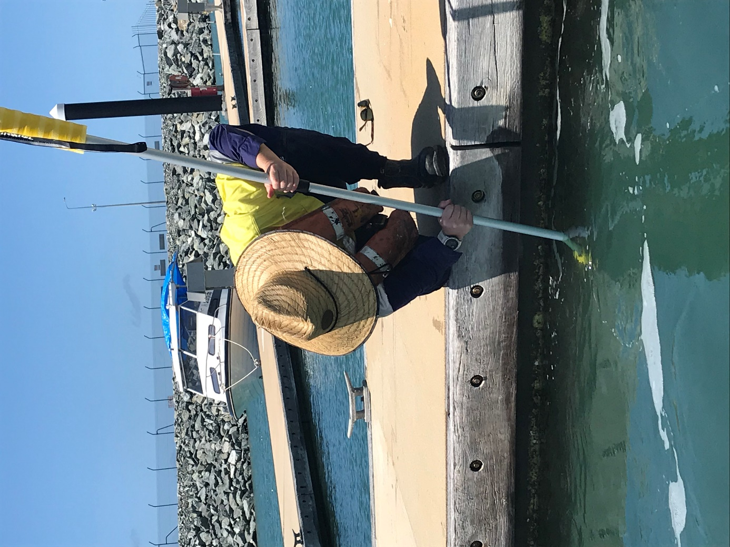

Source: Department of Agriculture and Fisheries Queensland.

## Vessel cleaning and maintenance

Facility owners, operators and personnel should be aware of and provide information to customers on appropriate areas for boat cleaning and details of local licensed boat cleaning/maintenance facilities.

To ensure a consistent approach, as facility owners, operators and personnel you should:

* be aware of the guidelines for the types of vessels using their facilities, such as the [Anti-fouling and in-water cleaning guidelines](https://www.agriculture.gov.au/biosecurity/avm/vessels/marine-pest-biosecurity/biofouling/anti-fouling-and-inwater-cleaning-guidelines), [National biofouling management guidelines](https://www.marinepests.gov.au/commercial/vessels) (for recreational vessels, commercial vessels and commercial fishing vessels), state and territory policy and legislation and the international Clean Marinas Program
* encourage cleaning before vessels leave for new destinations to minimise the chance of spreading pests
* ensure cleaning and maintenance undertaken at their facility is conducted in line with the National biofouling management guidelines
* be sure appropriate facilities and systems are in place so that all residues, solid coatings, liquid or any other forms of waste—including removed biological material and used product containers—can be contained, not enter any waterways and be stored for disposal in line with the requirements of the relevant state or territory authority
* ensure vessels are not cleaned in water, at tidal grids or by careening without approval from the relevant state or territory authority (see Contacts), in accordance with the Anti-fouling and in-water cleaning guidelines (2015).

Photo – Boat being cleaned and waste captured

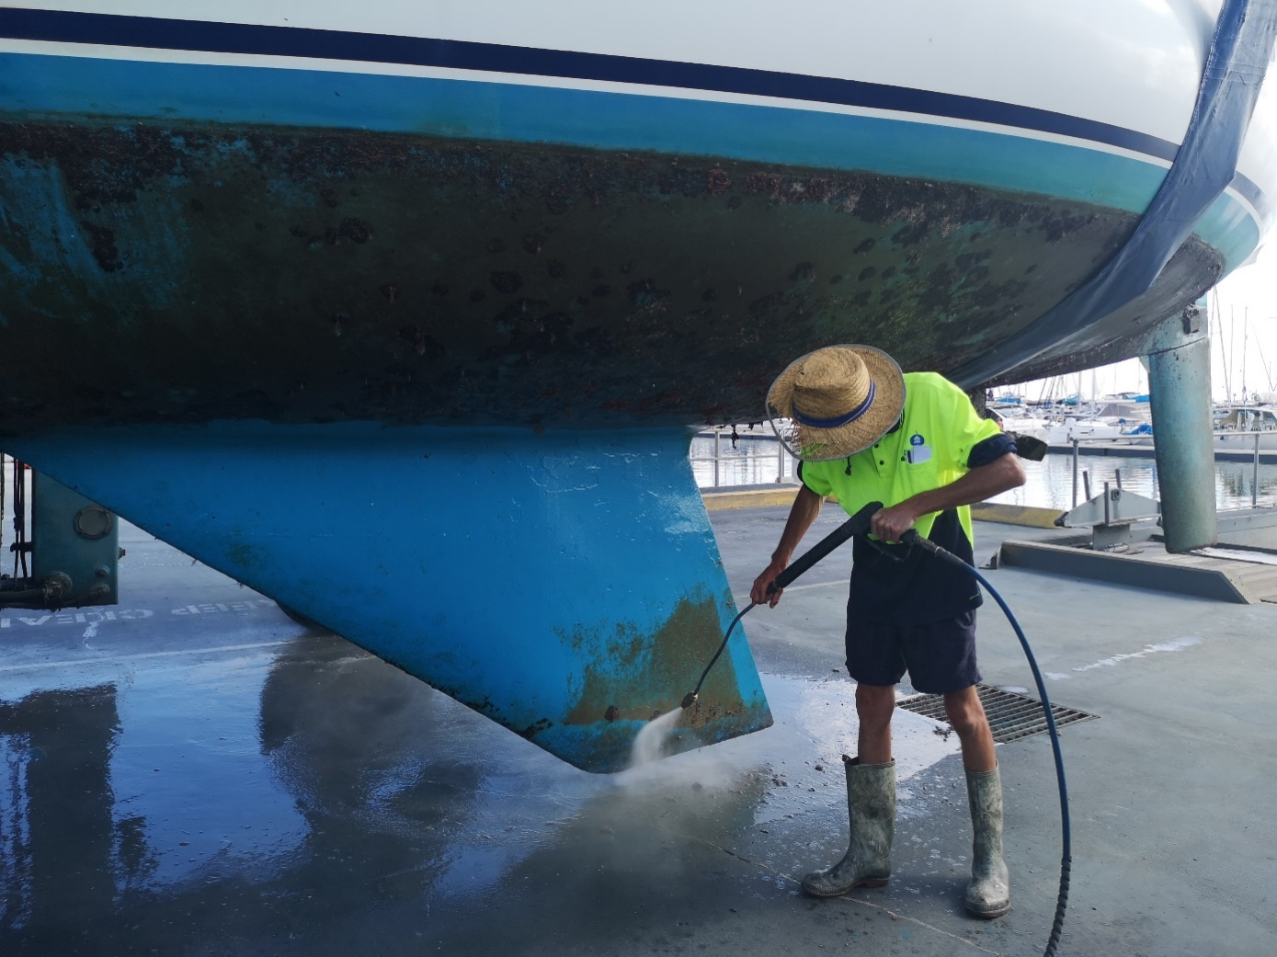

Source: Department of Agriculture and Fisheries Queensland.

### Vessel cleaning waste disposal

All biofouling waste should be disposed of appropriately to ensure that it cannot get back into waterways, stormwater drains or the marine environment.

To minimise marine pest risks while disposing of biofouling waste, you should:

* contain and collect all biofouling removed during hull cleaning and dispose of it appropriately into identified bins at a vessel maintenance facility or another landfill facility
* contain all wash down water that may be contaminated by fouling organisms—do not allow it to run back into waterways or stormwater drains
* where possible, dispose of bilge water and sewage wastes at appropriate pump-out facilities provided at marinas, slipways or boat ramps—bilge water and seawater used for toilet flushing may be contaminated with marine pests
* where pump-out facilities are not available, follow advice on alternative options for the safe disposal of bilge water and sewage wastes.

Figure 1 – Niche areas where biofouling can accumulate on a recreational vessel

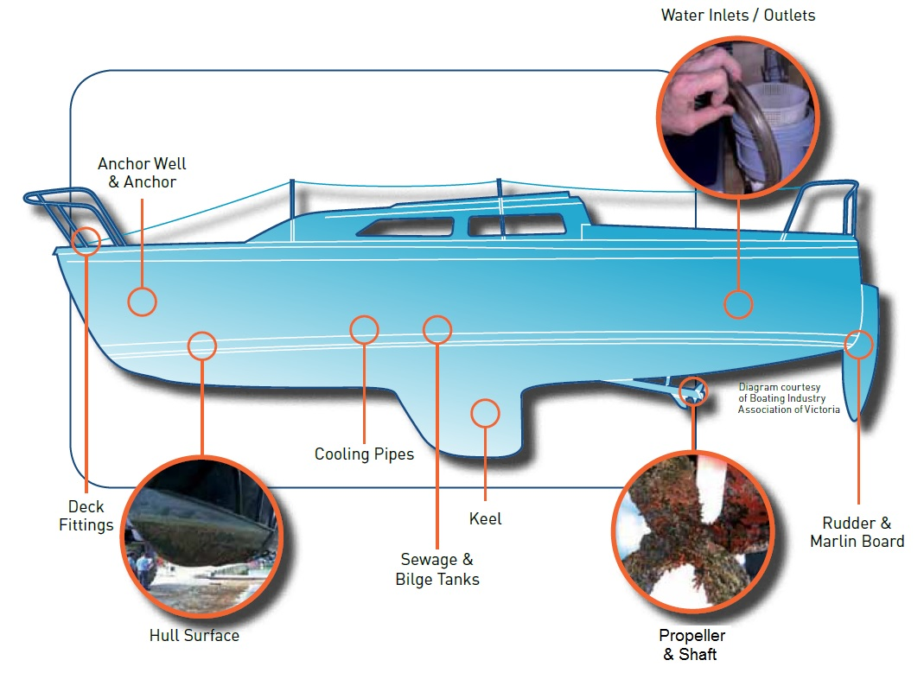

Source: Illustration adapted from a diagram provided by Mermaid Marine Australia Ltd.

## Record keeping and reporting

Accurate and up-to-date records provide valuable information during emergency marine pest responses and for auditing and monitoring biosecurity actions.

Keep written records of operational activities, for example:

* dates, methods and locations of infrastructure inspections
* dates and details of vessel arrivals, vessel origin, vessel location within the marina and departures
* dates of staff induction/training that includes biofouling risk management and marine pest information
* details of any anti-fouling coating application and maintenance work.

General information, such as the overall layout and features of your facility, should be readily available in the case of an emergency marine pest response —a detailed map and contact details for key personnel should also be available.

## Surveillance

Early detection of marine pests is critical to allow a rapid response and maximise the chance of eradication.

Surveillance includes being vigilant and taking observations while undertaking other related activities. While working in the marine environment, you should:

* watch for potential marine pest threats, particularly any arriving vessels that are heavily fouled or have a history of poor maintenance
* look out for target marine pests or any other unusual species on vessels or infrastructure when conducting maintenance on movable structures such as buoys, moorings, floating dry-docks, pontoons or boarding ladders, or when collecting debris (including ghost nests) from waterways.

Inspection for marine pests on fixed infrastructure including jetties, wharves, and pilings, should occur routinely—preferably twice a year—and should be adopted as part of regular maintenance procedures. Signs of marine pest infestation include:

* unusually heavy biofouling
* species that have never been seen before
* dominance of the biofouling by one or two species
* rapid recruitment on surfaces.

Some marine pests can look similar to native species. Becoming familiar with native species that are local to the area, and the distinguishing features of priority marine pests, will also help with early detection. More information and resources on priority marine pests can be found on state/territory marine pest websites (see Contacts), the [Marine Pests website](https://www.marinepests.gov.au/), and the [National Introduced Marine Pest Information System (NIMPIS)](https://www.marinepests.gov.au/pests/nimpis) website.

Where marine pests are known to be present, take care to minimise disturbance during maintenance, as this can trigger further spread of marine pests. Marine pests are often associated with disturbed areas because of their ability to quickly establish in new habitats and tolerate poor environmental conditions. Where possible, maintenance work should be avoided in any known peak periods of spawning and settlement of marine pests to limit the chance of the pests spreading and establishing in new areas. Knowing the established pests at or near your facilities and talking to your local state or territory authorities will help with such planning. Refer to your local biosecurity agencies for further information (see Contacts).

Routine maintenance of infrastructure should include a visual inspection for marine pest species. The facility emergency management plan (EMP) should also describe a regular more thorough marine pest inspection tailored to the size of the facility.

Specific surveillance programs that actively target detection of identified marine pests can provide a high level of confidence in the status of marine pests in a location. This surveillance also contributes to early detection. Early detection of marine pest infestations is critical for a range of control, containment and eradication options to be effective, in particular to minimise the spread of new marine pests. The most common detection method used is settlement plate monitoring, where growth on small submerged plates are visually checked at regular intervals. Samples can also be analysed using environmental DNA (eDNA) techniques to test for traces of pest species. Facility operators wishing to undertake a dedicated surveillance program should consult with their relevant state or territory agencies (see Contacts).

Any suspect findings should be photographed, reported to the appropriate state or territory agency and samples collected (if required and safe to do so). See Section 7 for further information on reporting and collecting samples.

Photo 3 – Inspecting mooring buoy biofouling at Weipa, Queensland

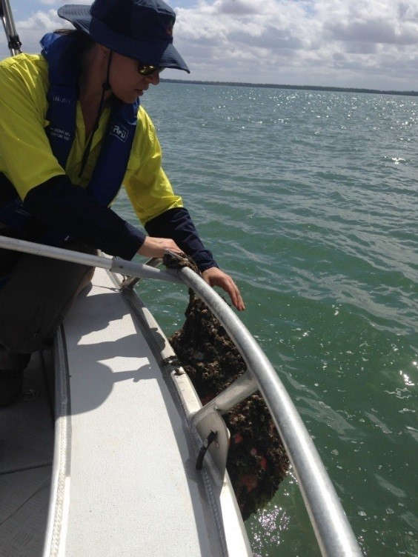

Source: Department of Agriculture and Fisheries Queensland.

## Reporting marine pests

Biosecurity is everyone’s responsibility, and facility owners and operators generally have an obligation to report the presence of any marine pests.

It is essential to notify the relevant state or territory agency (see Contacts) of suspected marine pest outbreaks as early as possible. This includes either a pest known to be in Australia that is found in a new location, or a pest species suspected to be new to Australia.

To help authorities determine an appropriate response and manage the situation, take photos or collect a sample for identification if required and safe to do so.

### Photographs

* Photos showing collection site and quantities of the suspected pest observed should be taken and reported.
* Photos of sample specimens should be taken from various angles and be clear, close enough to see individual features and include an object (such as a ruler) to provide scale.
* If possible, include labelling in the photo corresponding to the sample details (best to place the pre-labelled jar/bag in the photograph with the specimen—see below for labelling details).

### Sample collection

* Contact your relevant state or territory agency for instructions on collecting, handling and preserving any samples.
* If you cannot contact your relevant authority, and it is possible and safe to do so, collect one or two samples of the marine pest (initially whole, live specimens if possible). Place each sample in a separate plastic jar or zip-lock bag with a little seawater and store sealed in the fridge until further instruction is provided. If multiple samples are collected, store half in the fridge and freeze the other samples. Some marine pests may have sharp or pointed surfaces, and multiple layers of sample bags may be required to prevent leakage.
* Clearly label the sample jar/bag with:
* collection time and date
* name of person collecting sample and phone number
* suspected species or group (for example, oyster, sea squirt or crab)
* location/facility where samples were collected—including GPS location if possible
* If samples are collected from a vessel also record:
* vessel name and registration/IMO number
* vessel type
* site where specimens were collected from (e.g. around propeller, water inlet, or hull surface)
* vessel owner’s name and phone number.
* A ‘marine pest response kit’ is a practical means of ensuring the necessary equipment is readily available for collecting and reporting a suspect marine pest. Basic equipment includes:
* marine pest identification guide
* plastic sample bags – zip lock sandwich bags are suitable
* plastic screw-top jars
* permanent markers
* camera – ideally waterproof or with a waterproof external case
* ruler to use as a scale in photographs
* labels and pencils
* disposable gloves – to avoid cross-contamination of samples.

A list of key contacts for reporting suspected marine pests in each state and territory can be found in Contacts.

Photo 4 – Example of a marine pest detection response kit

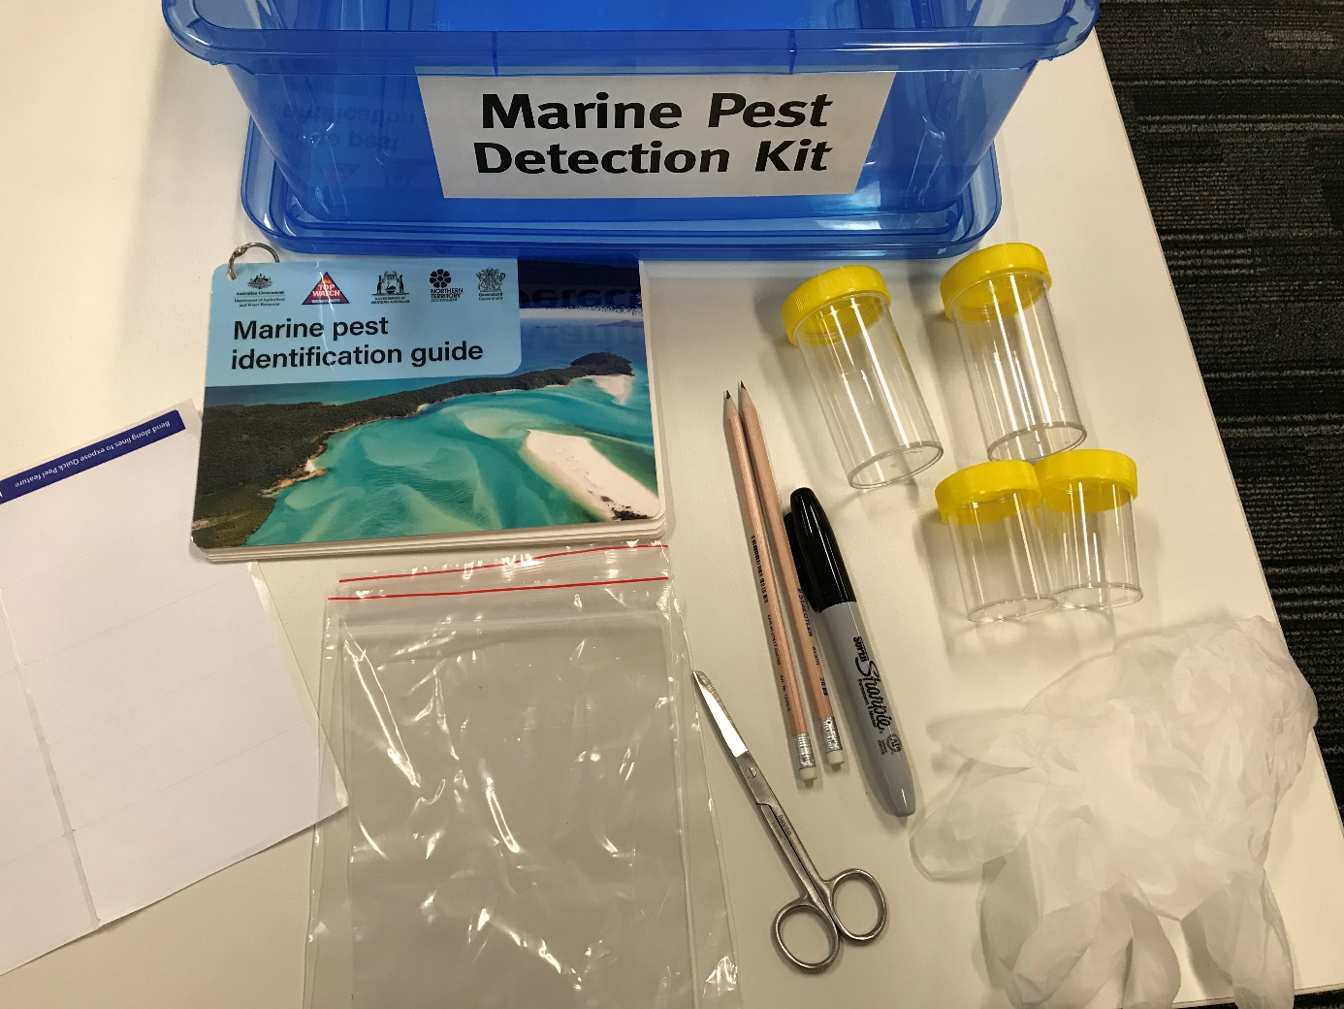

Source: Department of Agriculture and Fisheries, Queensland.

## Emergency preparedness

It is recommended that all marine facilities have an emergency marine biosecurity response plan in place that outlines how to respond to known (or suspect) marine pest outbreaks. This might be part of a broader biosecurity plan for the facility. This can be prepared and written in collaboration with an environmental consultant and/or the relevant state or territory agency.

Marine pest emergency response plans should include at a minimum:

* triggers for activation of emergency protocols – for example, identification of a high-risk marine pest
* roles and responsibilities of staff
* observations and record keeping – for example, location and number of detected specimens, actions taken to contain them if possible
* procedures for reporting to facility management and relevant state/territory agency
* communication of situation and expectations to vessel owners/operators – up-to-date contact details will assist
* guidelines for collecting specimens – see also Section 7
* contingency plans for maintaining business functions during a response
* emergency response plans should be reviewed annually to verify details and ensure that contacts for key government agencies remain current.

In the event of a marine pest emergency, the relevant state or territory authority may implement restrictions that limit certain activities within a defined area and movements of vessels, equipment, infrastructure and products into, within or from the defined area.

## Glossary

|  |  |
| --- | --- |
| Term | Definition |
| Anti-fouling coating | A coating applied to submerged surfaces to prevent or reduce accumulation of biofouling. |
| Biofouling | Accumulation of aquatic organisms (micro-organisms, plants and animals) on surfaces and structures immersed in or exposed to the aquatic environment. |
| In-water cleaning | The physical removal of biofouling and/or anti-fouling coating surface deposits from submerged surfaces. For the purposes of these guidelines, ‘in-water’ refers to the parts of a vessel or structure that are either below the load line or normally submerged and/or are coated in anti-fouling coating. |
| Macrofouling | Large distinct multicellular organisms visible to the human eye such as barnacles, tubeworms, mussels, fronds of algae and other large attached mobile organisms. |
| Marine pests | Marine pests are non-native (exotic) marine plants or animals that harm Australia’s marine environment, social amenity or industries that use the marine environment, or have the potential to do so if they were to be introduced, established (i.e. forming self-sustaining populations) or spread in Australia’s marine environment. |
| Microfouling | A layer of microscopic organisms including bacteria and diatoms and the slimy substances they produce. Often referred to as a ‘slime layer’, microfouling can usually be removed by gently passing a finger over the surface. |
| Movable structures | Structures or installations deployed in aquatic environments that can be moved between locations. Movable structures include (but are not limited to) buoys, moorings, floating dry-docks, pontoons, boarding ladders and navigational structures. |
| Niche areas | Parts of a vessel or structure more susceptible to biofouling accumulation due to different hydrodynamic forces, susceptibility to anti-fouling coating wear or damage or absence of anti-fouling coatings. They include, but are not limited to, vessel/structure waterlines, sea chests, bow thrusters, propeller shafts, inlet gratings, jack-up legs, moon pools, bollards, braces, joints and dry-docking support strips. |
| Translocation | Movement of organisms from one area to another area where they were previously not found. |
| Vessel | Any craft that operates in an aquatic environment be it to transport people or commodities, to carry out maintenance or provide a platform for other activities (such as barges, dredges, recreational, fishing, cruise, merchant, exploration, research or naval operations and other vessel types). |

## Key references

* [10 Tips for a Fish Friendly Marina 2016](https://www.dpi.nsw.gov.au/fishing/habitat/rehabilitating/fish-friendly-programs/fish-friendly-marinas)
* [Anti-fouling and in-water cleaning guidelines](https://www.agriculture.gov.au/biosecurity/avm/vessels/marine-pest-biosecurity/biofouling/anti-fouling-and-inwater-cleaning-guidelines) 2015
* [Australian Marine Pests – Educational Resource Database](https://www.oceanwatch.org.au/marine-pests-biosecurity/)
* [Australian marine pest monitoring guidelines](https://www.marinepests.gov.au/what-we-do/surveillance/monitoring-guidelines)
* [International clean marina program](https://www.marinas.net.au/accreditation-programs/clean-marina-program)
* National biofouling management guidelines for:
* [aquaculture industry](https://www.marinepests.gov.au/commercial/aquaculture/biofouling)
* [commercial vessels](https://www.marinepests.gov.au/commercial/vessels/biofouling-commercial)
* [commercial fishing vessels](https://www.marinepests.gov.au/commercial/vessels/biofouling-commercial-fishing)
* [non-trading vessels](https://www.marinepests.gov.au/commercial/vessels/biofouling-non-trading)
* [petroleum production and exploration industry](https://www.marinepests.gov.au/commercial/offshore-infrastructure/biofouling)
* [recreational vessels](https://www.marinepests.gov.au/commercial/vessels/biofouling-recreational)
* [Australian Priority Marine Pest List](https://www.marinepests.gov.au/what-we-do/apmpl)
* [National Introduced Marine Pest Information System (NIMPIS)](https://nimpis.marinepests.gov.au/)

## Contacts

For more information about marine pests and biofouling management guidelines contact your relevant local state/territory agency or visit the Marine Pests website at [marinepests.gov.au](http://www.marinepests.gov.au/).

Table 3. Jurisdictional contact details

|  |  |
| --- | --- |
| Jurisdiction | Contact details |
| New South Wales | Department of Primary Industries  Phone: 02 4916 3877 (recorded 24 hour hotline)  App: FishSmart  Email: aquatic.pests@dpi.nsw.gov.au  Web: [dpi.nsw.gov.au](https://www.dpi.nsw.gov.au/) |
| Northern Territory | Department of Industry, Tourism and Trade  Phone: 1800 891 136 (Fishwatch 24 hour hotline) or 0413 381 094 (Aquatic Biosecurity)  App: NT Fishing Mate  Email: aquaticbiosecurity@nt.gov.au  Web: [nt.gov.au](https://nt.gov.au/) |
| Queensland | Queensland Department of Agriculture and Fisheries  Phone: 13 25 23 (Customer Service Centre)  Email: marinepests@daf.qld.gov.au  Web: [daf.qld.gov.au](https://www.daf.qld.gov.au/) |
| South Australia | Primary Industries and Regions South Australia  Phone: 1800 065 522 (FISHWATCH 24 hour hotline)  App: SA Recreational Fishing Guide  Web: [pir.sa.gov.au](https://pir.sa.gov.au/) |
| Tasmania | Department of Primary Industries, Parks, Water and Environment  Phone: 1300 368 550  Email: biosecurity.policy@dpipwe.tas.gov.au  Web: [dpipwe.tas.gov.au](https://dpipwe.tas.gov.au/) |
| Victoria | Department of Jobs, Precincts and Regions  Phone: 136 186 (Customer Service Centre)  App: Vic Recreational Fishing Guide  Email: marine.pests@ecodev.vic.gov.au  Web: [agriculture.vic.gov.au](https://agriculture.vic.gov.au/) |
| Western Australia | Department of Primary Industries and Regional Development  Phone: 1800 815 507 (FishWatch) or 08 6551 4444 (Biosecurity Section)  App: WA PestWatch; Recfishwest Fishing  Email: biosecurity@dpird.wa.gov.au  Web: [dpird.wa.gov.au](https://dpird.wa.gov.au/) |