# National biofouling management guidelines for commercial vessels

Version 1.0, 2009

© Commonwealth of Australia 2009

**Ownership of intellectual property rights**

Unless otherwise noted, copyright (and any other intellectual property rights, if any) in this publication is owned by the Commonwealth of Australia (referred to as the Commonwealth).

**Creative Commons licence**

All material in this publication is licensed under a Creative [Commons Attribution 4.0 International Licence](https://creativecommons.org/licenses/by/4.0/legalcode) except content supplied by third parties, logos and the Commonwealth Coat of Arms.

Inquiries about the licence and any use of this document should be emailed to [copyright@agriculture.gov.au](mailto:copyright@agriculture.gov.au).

C:\Documents and Settings\west merryn\Local Settings\Temporary Internet Files\Content.Word\by.png

**Cataloguing data**

This publication (and any material sourced from it) should be attributed as: Marine Pest Sectoral Committee 2018, National biofouling management guidelines for commercial vessels, Department of Agriculture and Water Resources, Canberra, December. CC BY 4.0. Document modified in 2018 to meet accessibility requirements.

This publication is available at [marinepests.gov.au/what-we-do/publications](http://www.marinepests.gov.au/Pages/map/American-slipper-limpet.aspx)

Marine Pest Sectoral Committee Secretariat

Department of Agriculture and Water Resources

GPO 858 Canberra ACT 2601

Telephone 1800 372 746 (local calls) +61 2 6272 5232 (international)

Email [mpsc@agriculture.gov.au](mailto:mpsc@agriculture.gov.au)

Web [marinepests.gov.au](http://www.marinepests.gov.au/)

**Disclaimer**

These guidelines are part of a series of documents setting out a consensus view of effective biofouling management practices.

The guidelines are made available on the understanding that the Commonwealth of Australia is not thereby engaged in rendering professional advice. The Commonwealth does not warrant the accuracy, currency or completeness of the guidelines, or their relevance for any particular purpose. In particular, it should be noted that legislation, regulations and by-laws may vary between different jurisdictions and ports in Australia. Consequently, the guidelines do not purport to state what is necessary or sufficient to comply with laws applying in any place.

Before relying on the guidelines in any important matter, users should obtain appropriate professional advice to evaluate their accuracy, currency, completeness and relevance for their purposes.

Contents

Introduction 1

Purpose and scope 1

1 Risks 2

1.1 Reporting suspected marine pests 3

2 Hull antifouling systems 4

3 Sea chests 5

4 Sea inlet pipes and overboard discharges 6

5 Painted hull appendages and niches 7

5.1 Docking support strips 7

5.2 Bow and stern thrusters 7

5.3 Bilge keels, cooling scoops and propulsion scoops 8

5.4 Rudder hinges and stabiliser fin apertures 8

6 Unpainted hull appendages and niches 9

6.1 Cathodic protection (CP) anodes 9

6.2 Echo sounders and velocity probes 9

6.3 Propeller and shaft 9

7 Internal seawater systems 10

8 In-water cleaning 11

8.1 Propeller polishing 11

8.2 Hull cleaning 12

Glossary 13

Contacts 13

**Figures**

Figure 1 Niche areas where biofouling can accumulate on a commercial vessel 2

**Photographs**

Photo 1 Live specimen of Asian shore crab underwater 3

Photo 2 Commercial vessel in drydock for hull cleaning and antifouling paint renewal 4

Photo 3 Sea chest with grate removed to show significant levels of biofouling 5

Photo 4 Water jet blasting bow thrusters to remove biofouling from vessel in drydock 7

Photo 5 Retracted fin stabiliser with evidence of primary biofouling 8

Photo 6 Internal sweater system being checked for biofouling growth 10

## Introduction

Marine pests are known to be introduced and translocated in a variety of ways including ballast water from commercial, biofouling, aquaculture operations, and aquarium imports.

Marine pests can have significant impacts on the marine environment, human health and the economy. Such impacts include destruction of marine habitats and adverse effects on tourism, fishing, marine industries and coastal values.

Voluntary national biofouling management guidelines have been developed to address biofouling risks from a range of sectors. These guidelines will provide management measures to prevent new marine pest introductions and prevent the spread (translocation) of established populations.

National biofouling management guidelines have also been developed for the recreational vessel and commercial fishing vessel sectors. Similar documents have also been developed for non-trading vessels and the petroleum production and exploration industry. These can all be found on the [Marine Pests](http://marinepests.gov.au/what-we-do/publications) website.

The vessels encompassed by these guidelines are primarily commercial trading ships, which include bulk carriers, container vessels, oil and gas tankers, livestock carriers and general cargo ships. However, cruise vessels and other passenger ships are also included because their size, operational activity and maintenance regimes are similar to commercial trading ships.

These guidelines do not include non-trading vessels involved in commercial activities such as barges, heavy lift vessels, cable ships, and tugs. This sector is encompassed by the [Biofouling management guidelines for non-trading vessels](http://www.marinepests.gov.au/commercial/vessels/biofouling-non-trading). Similarly, these guidelines do not include vessels associated with the petroleum industry such as off shore support vessels. This sector is encompassed in the [Biofouling management guidelines for the petroleum production and exploration industry](http://www.marinepests.gov.au/commercial/offshore-infrastructure/biofouling).

### Purpose and scope

These voluntary guidelines aim to help operators of commercial vessels minimise the risk of translocating and introducing marine pests.

This document outlines operational procedures and provides information for operators of commercial vessels to follow to assist in the prevention of marine pest introductions and translocations.

It is critical that marine pest issues associated with the industry are dearly understood and that practical and effective management solutions that build on existing industry actions are implemented.

These guidelines are based on the premise that ship operators are complying with the intent of the [International Convention on the Control of Harmful. Anti-fouling Systems on Ships (AFS) 2001](http://www.imo.org/en/about/conventions/listofconventions/pages/international-convention-on-the-control-of-harmful-anti-fouling-systems-on-ships-(afs).aspx), ratified on 17 September 2008.

## Risks

By the time a new marine pest is detected in a new environment, the chances of its eradication are low and efforts must then focus on containment and management, which incurs considerable economic and ecological cost. Prevention of new incursions, by management of vectors to minimise the risk of introduction and translocation, better enables protection of Australia's marine environment.

Although the biofouling levels on any individual vessel may seem insignificant, many pest species require only a small starting pool to successfully breed and become an established threat. Further, the risk of incursions is multiplied by the frequency of vessel visits.

These guidelines provide options for managing and treating biofouling on commercial vessels and includes guidance for treatment of hulls, internal seawater systems and niche areas such as sea chests, sea intake grates, bow tunnels, anodes, transducers, docking support strips, propellers, rudders and shafts (Figure 1).

Figure 1 Niche areas where biofouling can accumulate on a commercial vessel

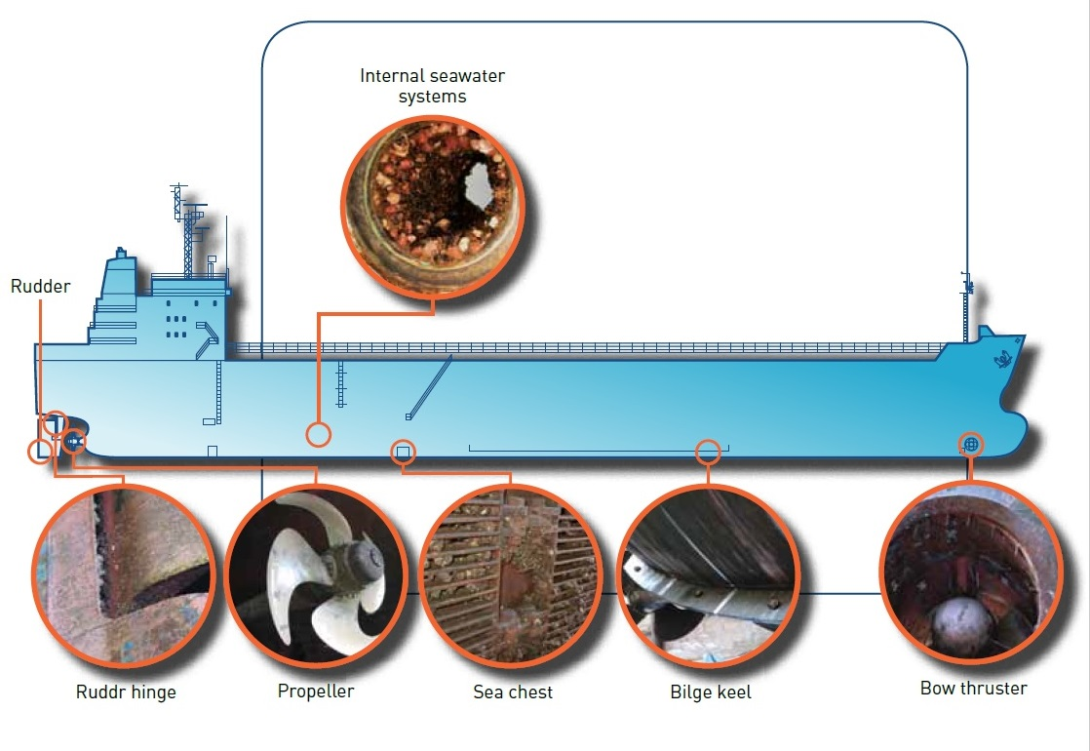

Note: Illustration adapted from a diagram provided by Mermaid Marine Australia Ltd.

### Reporting suspected marine pests

If you think you have found a marine pest species notify your regulatory agency (see the [Marine Pests](http://www.marinepests.gov.au/report) website for contact details), so that it can be formally identified, monitored and potentially eradicated. Signs of a suspected pest could include unusually heavy biofouling, dominance of the biofouling by one species, or a 'new' species not seen before in your region. If possible, collect some specimens and keep them in a sealed plastic bag in the freezer until they can be taken for identification.

Photo 1 Live specimen of Asian shore crab underwater

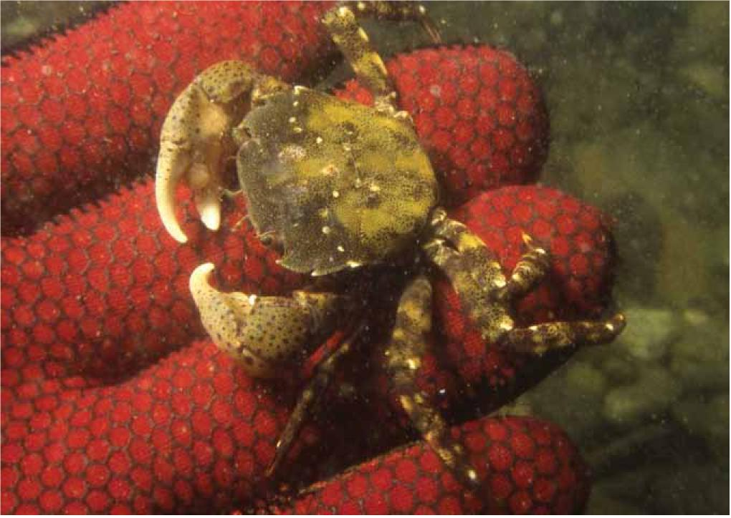

Image: Forgacs Engineering Pty Ltd.

## Hull antifouling systems

Hulls should be painted with antifouling systems that are able to prevent biofouling between dockings, using materials that are in accordance with the AFS Convention. The system applied should take into account the planned docking period, the ship's speed and activity (nautical miles per month), and any projected lay-up periods. The choice of paint and application specification of the antifouling system should be developed in consultation with the paint manufacturer or their technical representative.

Where antifouling paint is damaged as a result of grounding, collision or mechanical impact, in-water repair of the paint system should be considered for the area of damage even if the area of damage is relatively minor.

At maintenance dockings (Photo 2), prior to antifouling system repair and recoating, care should be taken in hull cleaning to ensure all residual biofilm, biofouling residues or other surface contamination is completely removed, particularly in niche areas, to facilitate good adhesion and durability of the repair systems.

Drydock facilities should be able to contain wastes such that all material removed from the hull, including antifouling paint and biofouling, is disposed of in an appropriate land based facility.

Photo 2 Commercial vessel in drydock for hull cleaning and antifouling paint renewal

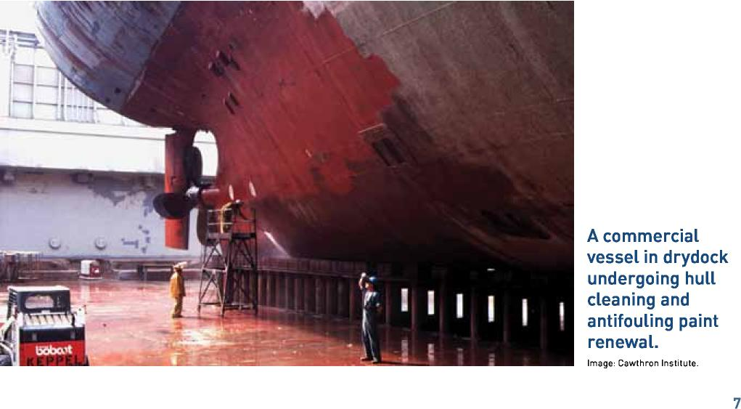

Image: Cawthron Institute.

## Sea chests

The internal surfaces of sea chests should be painted with antifouling paints suitable for the flow conditions of seawater through the chest. Care should be taken in application of both anticorrosive and antifouling paint to ensure adequate film build and adhesion to corners and edges.

Where possible, marine growth prevention systems (MGPS) should release dosed water into the sea chest. Care should be taken to ensure that MGPS are operating at a level that is effective in preventing build-up of marine organisms.

If steam blow-out pipes are fitted within sea chests, regular use may minimise growth in the sea chest. External surfaces of the blow-out pipes and holding brackets must be effectively antifouled as they are prone to biofouling colonisation.

Antifouling paint adhesion and durability are improved if sea chest angles and corners are bevelled or radiused, and sea chest grates use round instead of angular bars. Hinged grates will enable diver access for in-water inspection and maintenance between dockings.

Photo 3 Sea chest with grate removed to show significant levels of biofouling

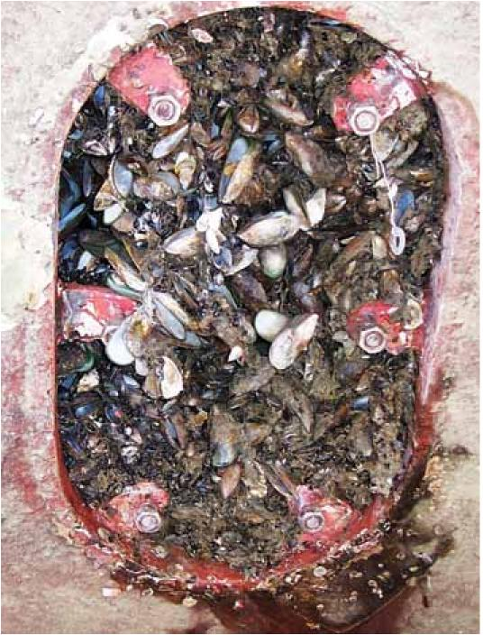

Note: This presents a risk not only for the effective operation of the vessel’s motor but is also an effective niche area in translocating marine pests.

Image: Cawthron Institute.

## Sea inlet pipes and overboard discharges

Antifouling paint system adhesion and durability is improved if all sea inlet pipes and discharge penetrations are radiused and grates on sea intakes are constructed of round bars.

The antifouling paint system should also be applied inside the pipe opening and accessible internals and the anticorrosive or primer coating selected should be appropriate to the specific pipe material if this material is different to the hull plate.

## Painted hull appendages and niches

Painted hull appendages are niche areas that, although painted, are for a variety of reasons, particularly susceptible to biofouling growth.

Before removing any biofouling in-water, permission is required from the relevant state/territory authority (see section 8).

### Docking support strips

Positions of docking blocks and supports should be varied at each docking to ensure that areas under blocks are painted with antifouling, at least at alternate dockings. These areas should receive major refurbishment type of surface preparation and be painted at each docking that these areas are accessible.

### Bow and stern thrusters

The body and area around bow and stern thrusters are prone to paint damage through cavitation forces. High performance coating systems should be applied to resist cavitation damage and systems should be routinely maintained at dockings.

Antifouling paint system adhesion and durability is improved if tunnel openings are radiused where they penetrate the hull and grates are made of round section.

Photo 4 Water jet blasting bow thrusters to remove biofouling from vessel in drydock

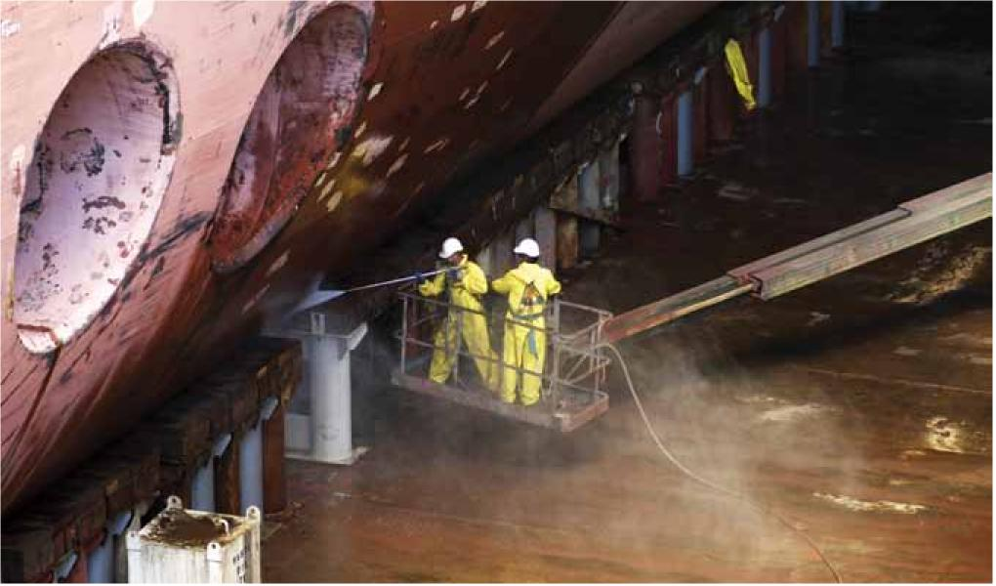

Image: Forgacs Engineering Pty Ltd.

### Bilge keels, cooling scoops and propulsion scoops

The outer edge of bilge keels and scoops, and the weld joints to the hull should be stripe-coated with additional anticorrosive and antifouling paint to ensure adequate film build to optimise system durability and antifouling life.

### Rudder hinges and stabiliser fin apertures

Recesses within rudder hinges and behind stabiliser fins need to be carefully and effectively cleaned and re-antifouled at maintenance dockings. These niches should be inspected between dockings and all biofouling removed, ensuring that debris is captured and disposed of at licensed on-shore facilities.

Rudders should be moved port and starboard during the painting process to ensure that all surfaces are correctly painted to the correct specification of the antifouling system.

Photo 5 Retracted fin stabiliser with evidence of primary biofouling

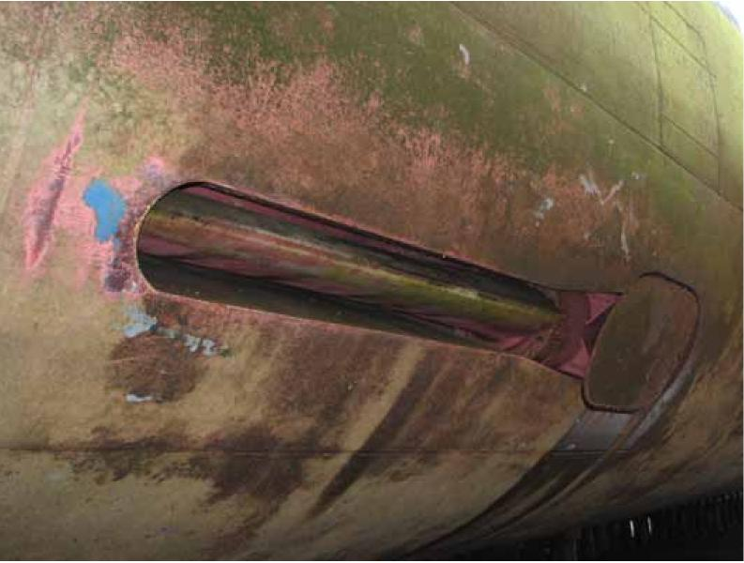

## Unpainted hull appendages and niches

Some hull appendages are not painted with antifouling paint for operational reasons. Such appendages include anodes, velocity probes and echo sounders.

### Cathodic protection (CP) anodes

Niche areas can be minimised if anodes are flush-fitted to the hull, or if a rubber backing pad is inserted between the anode and the hull. If not flush-fitted, the hull surface under the anode and the anode strap should be stripe coated with a static antifouling to prevent biofouling colonisation. If anodes are attached by bolts recessed into the surface, the recess should be caulked to remove a potential niche.

Sacrificial CP and impressed CP anodes should be regularly inspected in-water and maintained to prevent biofouling. If the cathodic protection anodes are fouled any growth should be removed, ensuring that all biofouling debris is captured and disposed of to shore facilities.

### Echo sounders and velocity probes

Unpainted surfaces of echo sounders and velocity probes should be regularly inspected. If the echo sounders and velocity probes are fouled, growth should be removed ensuring that debris is captured and disposed of at a licensed on-shore facility.

Where retractable pilot tubes are fitted, they should be internally painted with a static antifouling paint.

### Propeller and shaft

Propellers should be regularly polished to maintain operational efficiency and to prevent biofouling (see section 8.1). Painting propellers and propeller shafts with silicone fouling release coatings can maintain efficiency and enable self-cleaning, alleviating the need for regular polishing. Unpainted propeller shafts should be cleaned at the same time as the propeller.

Thruster propellers or propulsion units should be routinely inspected for biofouling. If propellers or propulsion units are fouled, in-service arrangements should be made to carry out safe and environmentally acceptable cleaning with all biofouling captured ensuring that it does not dislodge into the water.

Exposed sections of stern seal assemblies and the internal surfaces of rope guards should be carefully painted with antifouling paint systems appropriate to the degree of water movement over and around these surfaces.

## Internal seawater systems

Effective MGPS can be fitted to internal seawater systems prone to biofouling. These systems need to be operated regularly and monitored to ensure effective biofouling control is maintained. Seawater systems that operate while the vessel is in port are particularly vulnerable to biofouling infestation, and should be closely monitored (Photo 6).

If seawater systems become fouled they should be treated with a product to kill all biofouling.

Photo 6 Internal sweater system being checked for biofouling growth

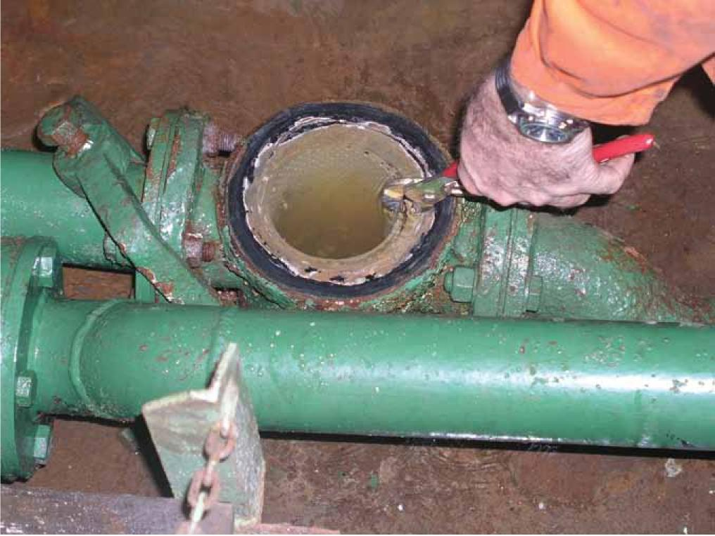

Image: URS Australia.

## In-water cleaning

Prior to undertaking in-water cleaning (including propeller polishing) approval from the relevant state/territory authority must be granted and conditions may be imposed in line with the Australian and New Zealand Environment and Conservation Council (ANZECC) [Antifouling and in-water cleaning guidelines](http://www.agriculture.gov.au/biosecurity/avm/vessels/biofouling/anti-fouling-and-inwater-cleaning-guidelines). Applications seeking approval must be lodged with the administering authority (Harbour Master, local government or state environmental protection agency) at least five working days prior to the proposed commencement of the work.

No part of the vessel's hull that is treated with biocidal antifouling paint is to be cleaned in Australian waters. Permission to clean hulls painted with biocidal antifouling paints will only be granted by the state/territory authority in exceptional circumstances.

### Propeller polishing

Regular polishing of the propeller will not only improve vessel performance but will minimise the risk of species translocation. Propeller polishing also provides an opportunity to inspect biofouling prone niches and remove any significant growth.

While undertaking propeller polishing divers should inspect all niche areas for biofouling. Where significant biofouling growth is detected it should be removed using appropriate technology to ensure that all material is collected for disposal onshore and no material is allowed to remain in the water column.

Areas that should be specifically inspected by divers undertaking propeller polishing include:

* rudder stock and hinge
* stabiliser fin apertures
* rope guards and propeller shafts
* cathodic protection anodes
* sea chest and bow thruster tunnel grates
* sea chests
* overboard discharge outlets and sea inlets
* areas of antifouling paint system damage or grounding.

Operators should plan in-water inspections for each individual vessel and identify locations of potential biofouling niches on the hull to enable divers to efficiently target these areas during inspections.

Under the ANZECC Antifouling and in-water cleaning guidelines, the cleaning of sea chests, and other niche areas may be permitted provided any debris removed (including encrustation, barnacles and weeds) is not allowed to pass into the water column or fall to the seabed and subject to any other conditions attached to the permit. Applications seeking permission to carry out this work need to detail how debris will be contained and/or collected for disposal, as well as the method of disposal.

### Hull cleaning

In-water cleaning or scrubbing of hulls painted with biocide-containing antifouling paints for the purpose of delaying dockings or attempting to rejuvenate depleted antifouling coatings must not be undertaken.

Scrubbing fouled antifouling paints can not only generate biofouling debris, but prematurely depletes the antifouling coating and creates a pulse of biocide that can harm the local environment and may impact on future applications by the port authority for the disposal of dredge spoil.

Depleted antifouling coatings on hulls will also rapidly re-foul, reducing efficiency and increasing marine pest translocation risks.

Ships with biocide-free underwater coatings, such as ice breakers or ships with fouling release coatings may require in-water cleaning to minimise marine pest translocation risks in some circumstances.

In-water cleaning must be undertaken in accordance with the Australian requirements and permission to undertake the in-water cleaning must be granted by the relevant state/territory authority.

## Glossary

| Term | Definition |
| --- | --- |
| ANZECC | Australian and New Zealand Environment and Conservation Council |
| Biofouling | the attachment of marine organisms to any part of a vessel hull (including the hulls, rudders, propellers and other hull appendages) or internal seawater systems (including sea chests and pipe work), or any equipment or equipment spaces attached to or onboard the vessel (including mooring devices, anchor wells, cable lockers, cargo spaces and bilges |
| Exotic marine species | any non-native species that may or may not be present in Australia's marine environment |
| Introduction | the accidental or intentional movement of a species into any location that is not part of its natural (native) range |
| Marine pest | any exotic marine species that may pose a threat to Australia's marine environment or industry, if introduced, established or translocated |
| Niche area | protected or refuge areas on a vessel, or areas not protected by antifouling paint, that facilitate the settlement and survival of biofouling organisms |
| Translocation | the accidental or intentional transportation of an organism from one location to another |
| Vector | the physical means, agent or mechanism which facilitates the translocation of organisms from one place to another |

## Contacts

For more information about marine pests and biofouling management guidelines contact your local state/territory fisheries officer or visit the [Marine Pests](http://www.marinepests.gov.au/) website.