Notes from MPSC for the period June 2023 - November 2023

The Marine Pest Sectoral Committee (MPSC) held its 26th Committee Meeting and Partners’ Workshop via a hybrid format at the Deakin Queenscliff Marine Science Centre, Victoria, on 15-16 November 2023. MPSC uses a hybrid format to host its meetings and partners' workshops to enable participation from MPSC members, observers, and partners who are unable to attend in-person.

# Notes from the Chair

The MPSC26 Partners’ Workshop focused on research and development of marine pest biosecurity issues. There was a diverse range of presentations on marine biosecurity research projects, programs, and initiatives. Representatives from industry partners, Australian Government, and State and Territory biosecurity agencies discussed marine pest research priorities and were also given a tour of the Deakin Queenscliff Marine Science Centre.

The Committee Meeting progressed key MPSC priorities including the development of emergency response manuals and implementation of [National Marine Pest Surveillance Strategy 2021-26 activities.](https://www.marinepests.gov.au/what-we-do/surveillance/national-marine-pest-surveillance-strategy)

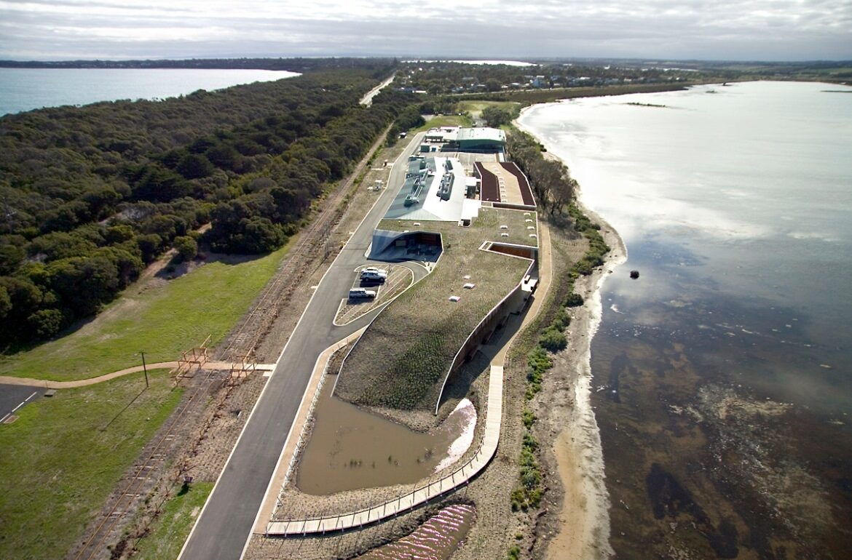The implementation period for [MarinePestPlan 2018-2023](https://www.marinepests.gov.au/what-we-do/publications/marine-pest-plan) has now finished. MPSC has made significant progress on the delivery of MarinePestPlan 2018-2023 activities across multiple aspects of marine pest management including vector management, surveillance, preparedness, emergency response and stakeholder engagement. A review of MarinePestPlan 2018-2023 is now underway. The review will document the plan’s achievements, identify the strengths and weaknesses of its implementation, and guide approaches for the development of a possible successor strategy. I am excited to see how MPSC will contribute to the review process in 2024.

**View of Queenscliff Marine Centre. Image credit:** [MAFRI The Queenscliff Centre - Kane Constructions](https://www.kane.com.au/project/mafri-the-queenscliff-centre)**.**

Another exciting achievement was the completion of the [Passive Surveillance, Education and Awareness materials,](https://www.marinepests.gov.au/what-we-do/education) which was a long-standing activity that commenced in 2018. The final materials looked great, and I am really pleased to see that the materials have been very well received by stakeholders. Thank you to all of those involved over the course of this activity.

I am grateful for the dedication of the MPSC members, observers, and partners, whose valuable contributions made this session both productive and constructive. I am looking forward to continued collaboration with all of you in the future.

**Queenscliff Marine Science Centre in Victoria**

**Matthew Osborne**Chair MPSC26

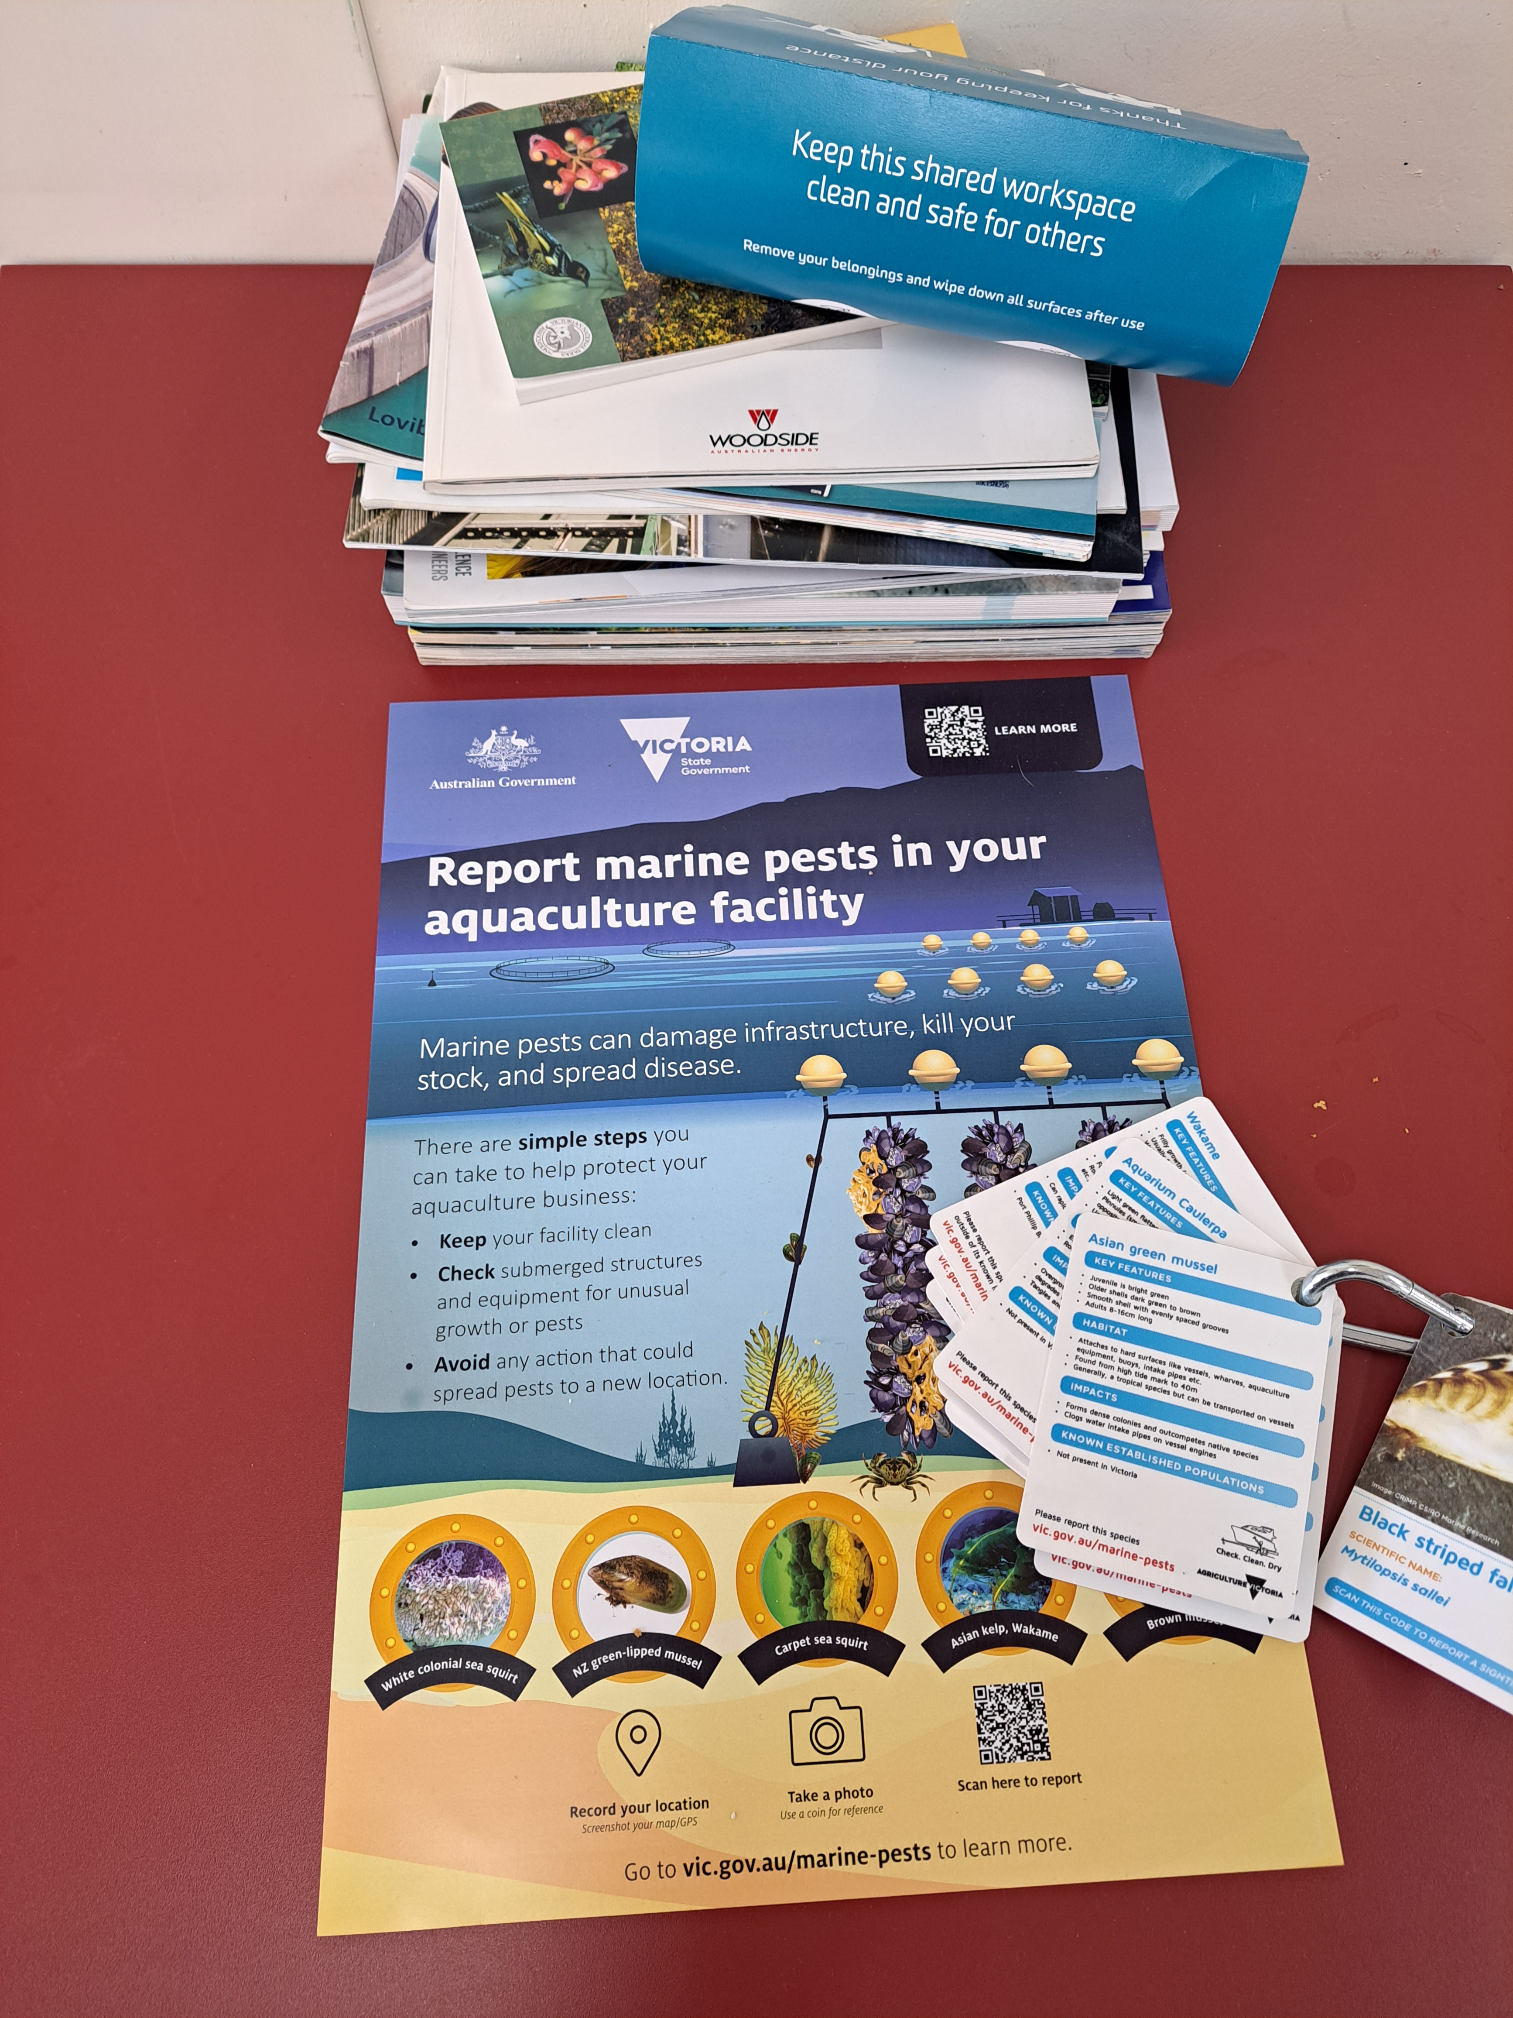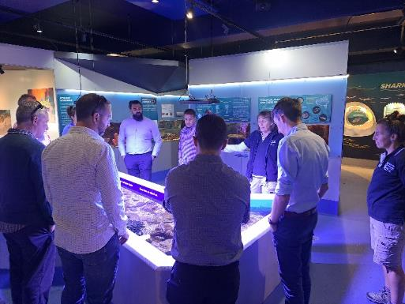

**Marine pest passive surveillance posters on display at the Queenscliff Marine Centre. Image credit: René Campbell**

**MPSC attendees receiving a tour of the Queenscliff Marine Centre. Image credit: René Campbell**

# MPSC26 Partners’ Workshop

The MPSC26 Partners’ Workshop was held via hybrid format on 15 November 2023, with the theme focused on research and development (R&D).

The workshop begun with a presentation from Carnival/P&O Cruises about their biofouling plan, which included strategies, actions, and procedures for managing biofouling on cruise vessels.

Deakin University presented on a research project that uses pheromone signalling as a potential control method for invasive northern Pacific seastars (*Asterias amurensis*).

The Marine Pest Research Network (MPRN) Task Group has been established to facilitate the development of marine pest R&D priorities, and to enable coordination and communication of marine pest research within Australia. During the Partners’ Workshop, the MPRN TG asked marine pest-related industries to share their research priorities that were missing from the National Marine Pest Surveillance Strategy 2021-26 and [Introduced Marine Pest Research and Development (NPIMPRD) 2013-2023 plan](https://www.marinepests.gov.au/sites/default/files/Documents/national-priorities-marine-pest-research-2013-2023.pdf).

Parks Victoria presented on their current marine pest management programs. The presentation showed marine pest species that are causing impacts in the marine protected areas or park systems in Victoria. Parks Victoria outlined how they are working with stakeholders to prevent or manage marine pest incursions.

The co-executive director of [Catalysing Australia’s Biosecurity (CAB)](https://www.csiro.au/en/about/challenges-missions/biosecurity) presented an update on the initiative. CAB is trying to achieve long-term national biosecurity outcomes by delivering innovative technologies, digital systems, and capabilities that transform management capabilities. MPSC will be engaging with CAB via the MPRN TG to identify marine biosecurity priorities that may be included in the initiative.

The South Australian Research and Development Institute (SARDI) delivered a presentation on diagnostic performance for molecular detection of marine pests from settlement plates. SARDI explained how diagnostic performance of assays has been tested on eDNA from water samples but has not been tested on eDNA from settlement plates. Settlement plates are an important tool for marine pest surveillance. SARDI proposed methods to assess performance of settlement plate surveillance.

The final presentation by the Department of Agriculture, Fisheries and Forestry (DAFF) discussed Stony Coral Tissue Loss Disease which is spreading throughout Caribbean coral reefs and results in high mortality of reef-building coral species. There is a concern the disease could reach Australia via shipping. Thankfully, the current strategies for handling ballast water and biofouling are reducing the risk of this disease being transmitted into Australia. To minimise the risk of this disease, more research is needed to understand the disease agent and its transmission.

Any feedback and suggestions on future Partners’ Workshops or how to improve engagement are welcome and can be sent to [MPSC@aff.gov.au](mailto:MPSC@aff.gov.au). These suggestions will be used in preparation for future Partners’ Workshops.

# MPSC High Priority Work Items

Since MPSC25, MPSC has progressed the following high priority work items.

## National Strategic Plan for Marine Pest Biosecurity: MarinePestPlan 2018–2023

The MarinePestPlan 2018–2023 implementation period ended on 30 June 2023, but there are extension activities underway.

Out of the 29 activities listed in MarinePestPlan 2018–2023:

* 24 activities are completed.
* 3 have commenced.
* 2 are yet to commence.

The MarinePestPlan review survey has now closed. MPSC networks were used to promote the survey. The survey received a large number of responses. The review report containing the survey outcomes is currently being drafted and will be circulated in 2024.

More information on MarinePestPlan 2018–2023activities and current status can be found on the [Marine Pests](https://www.marinepests.gov.au/what-we-do/publications/marine-pest-plan) website.

## National Marine Pest Surveillance Strategy 2021–2026

The National Marine Pest Surveillance Strategy outlines Australia’s national surveillance priorities and sets the strategic direction for investment in surveillance.

Out of 15 activities listed in the National Marine Pest Surveillance Strategy 2021–2026:

* 1 activity has been completed.
* 13 have commenced.
* 1 has not commenced.

The Surveillance Strategy Task Group developed an agreed list of priority marine pest species and methods for surveillance. The list has 80 priority marine pest species and approximately 13 different surveillance techniques. The list of priority pest species will be distributed to stakeholders in 2024.

More information on the status of National Marine Pest Surveillance Strategy 2021–26 activities can be found on the [National Marine Pest Surveillance Strategy](https://www.marinepests.gov.au/what-we-do/surveillance/national-marine-pest-surveillance-strategy) website.

## Passive Surveillance Education and Awareness (PSEA)

Passive surveillance materials for marine pests are now complete for the ports, marinas, divers, and aquaculture sectors. All materials have been distributed to the jurisdictions and stakeholders for use.

## Emergency Response (EMPPlan)

The Response Manual for Invasive Marine Bivalves is close to being circulated to the MPSC for comment. The Response Manual for Invasive Marine Ascidians is currently being planned.

## Marine Pest Research Network (MPRN)

The Marine Pest Research Network Task Group (MPRN TG) has been established. The MPRN TG will be facilitating the marine pest research network. The task group will be engaging with relevant stakeholders to discuss R&D priorities in marine pest biosecurity.

## Current Status of Marine Pests (*Proof of Freedom Guidelines Task Group*)

MPSC has formed a task group to develop National Guidelines on determining the current status of marine pests. This work will contribute towards Surveillance Strategy activity 2.3.

**Communication, Education and Engagement (CEE TG)**

MPSC has formed the Communication, Education and Engagement Task Group with the purpose of leading and implementing communication and engagement projects under activity 4.1 in the Surveillance Strategy.

# Jurisdictional updates

Since the last update to MPSC25, there has been progress on a range of marine pest biosecurity work across jurisdictions:

## Australian Government (AG)

* The Australian Government Department of Agriculture, Fisheries and Forestry (DAFF) has concluded the implementation of MarinePestPlan 2018-2023 on 30 June 2023.The review of the plan is underway and will be circulated in 2024.
* DAFF has made progress on domestic and international biofouling and ballast water management, and associated activities under MarinePestPlan 2018-2023.
* DAFF is currently finalising the Australian Antifouling Guidelines and In-water Cleaning Standards and will be submit the document to MPSC for consultation.
* DAFF has been progressing the response manuals as part of the EMPPlan series.
* DAFF has been supporting the carpet sea squirt (*Didemnum vexillum*) response at three locations around Australia.
* The Northern Australia Quarantine Strategy (NAQS) attended the Northern Australia Indigenous Biosecurity Ranger Forum in October 2023. An aquatic workshop concentrating on exotic marine pest and aquatic disease entry pathways was included in that forum.

## New South Wales (NSW)

* The New South Wales Department of Primary Industries (DPI) has continued marine pest surveillance activities under marine pest surveillance plan (2022-2026) throughout the period.
* DPI has been working with DAFF and the Australian Navy to support the response of delimiting carpet sea squirt (*Didemnum vexillum*), an invasive ascidian outbreak currently occurring at Fleet Base East (FBE), in Sydney Harbour.
* DPI had policy discussions with partner agencies, relating to the draft Australian Government Anti-fouling guidelines and in-water cleaning standards (the national standards).
* DPI conducted activities for stakeholder engagement through biosecurity awareness events as part of the Marine Estate Management Strategy (MEMS),
* DPI also developed marine pest awareness materials and presented the materials at the key events.
* DPI plans to engage a social research contractor to conduct a monitoring and evaluation program following engagement activities. This program will help to assess recreational vessel owners’ awareness of biofouling and reporting marine pest and disease.

## Northern Territory (NT)

* The Northern Territory Department of Industry, Tourism and Trade (DITT)completed the quarterly surveillance activity in Darwin Harbour and no new marine pests were detected.
* DITT continued its vessel inspection and treatment program, and the number of vessels being inspected is increasing. One vessel, cleaned in Jakarta, had charru mussel (*Mytella strigata)* andblack striped false mussel (*Mytliposis sallei*) attached to an uncleaned area of hull. The hull was immediately treated, and the pests were eradicated. White colonial sea squirt (*Didemnum perlucidum)* was detected on the hull of another vessel and this vessel was also subsequently cleaned. Asian green mussel (*Perna viridis*) was detected on a cruise ship and was removed.

## Queensland (QLD)

* The Queensland Department of Agriculture and Fisheries (DAF) currently investigating reports of black scar oyster (Magallana bilineata) from Moreton Bay which represents a significant range expansion.
* DAF continues to deliver the Queensland Seaports eDNA Surveillance (Q-SEAS) program in partnership with port authorities. In this program, they are engaging indigenous ranger groups to provide marine pest surveillance in remote northern Queensland.

South Australia (SA)

* The Department of Primary Industries and Regions, South Australia (PIRSA) undertook consultation on the South Australian Biosecurity Bill.
* PIRSA continues their response to the detection of Asian kelp/wakame (*Undaria pinnatifida*) in the southeast of South Australia.
* PIRSA continued development of an in-water cleaning guideline document.
* PIRSA conducted prevention activities with the provision of advice and investigating marine pest passive surveillance reports.
* PIRSA drafted South Australia’s carpet sea squirt (*Didemnum vexillum)* response plan.

## Tasmania (TAS)

* The Department of Natural Resources and Environment, Tasmania (NRE TAS) attended a workshop with staff from the Sustainable Ocean Planning Taskforce, who are contributing to the development of a Sustainable Ocean Plan for Australia
* The short-term moratorium on the in-water cleaning in Tasmanian waters of vessels arriving from interstate or overseas (to allow the undertaking of risk assessment and policy development) is currently being reviewed; discussions with industry and key stakeholders will provide the basis of an interim policy to assess requests on vessels arriving from interstate or overseas by January 2024.
* NRE TAS is liaising with industry regarding any possible impacts of the Japanese soft-shelled clam (*Mya japonica)* located at Dunalley, Tasmania.
* NRE TAS has been utilising the Passive Surveillance Education and Awareness (PSEA) communication materials at community meetings.
* NRE TAS officers will be attending a marine pollution incident exercise in Hobart on the 14-16 November 2023.

## Victoria (VIC)

* The Victorian Department of Energy, Environment and Climate Action (DEECA) have undertaken preparedness and communication activities for responding to marine pests in Victorian waters, including carpet sea squirt (*Didemnum vexillum*).
* DEECA has been responding to Asian kelp/wakame (*Undaria pinnatifida)* in Westernport and Port Phillip Bay.
* DEECA continues the commercial ports surveillance program.
* DEECA has been using the Atlas of Living Australia (ALA) Biosecurity Alerts System and has been finding it useful.
* DEECA has conducted research into established marine pest species.

## Western Australia (WA)

* The Western Australian Department of Primary Industries and Regional Development (DPIRD) continues to focus its resources using a risk/resource-based approach to ensure the prevention and early eradication of priority invasive marine pests.
* DPIRD has been involved in a range of marine biosecurity science, compliance, policy, and communications activities for the ongoing response to carpet sea squirt (Didemnum vexillum) at the Australian Marine Complex Common User Facility (AMC CUF) Southern Harbour, and at HMAS Stirling.
* DPIRD conducted surveillance as part of the State-Wide Array Surveillance Program (SWASP) at 10 ports across the state and conducted surveillance activities at HMAS *Stirling*,Garden Island, and Cockburn Sound, WA.
* DPIRDA has developed draft regulations for the transition of pending legislation.
* DPIRDA has completed he marine biosecurity survey for the Port of Cocos (Keeling) Islands.
* The detection of *D. vexillum* at the Kwinana Grain Jetty has returned a negative result for qPCR as the result of a false-positive.

# Upcoming MPSC Meetings

## MPSC27

The 27th MPSC meeting and corresponding Partners’ Workshop will be held in Darwin, NT. The date of the MPSC27 meeting and partner’s workshop is not finalised yet but will be held sometime in April or May 2024 via hybrid format.